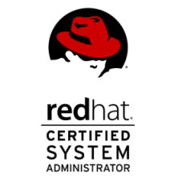 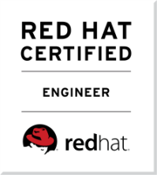 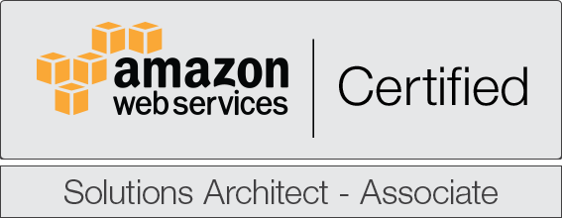

**Ravindra Ambadas Yerkandwar**

**Mobile**: + (91) 9920808763, 8149943463

**Email**: raviyerkandwar6641@gmail.com

**PROFILE:**

As a professional I am innovative and looking ahead to work in a challenging environment to gain professional edge in DevOps Engineer to add value to my career through self-enhancement.

**TECHNICAL SKILLS:**

|  |  |
| --- | --- |
| Programming Languages | Java, Shell scripting. |
| Operating Systems | REDHAT (rhel5, 6, 7), CENT OS (5, 6, 7), AWS cloud. |
| RDBMS | Mysql, SQL. |
| Office Automation Tools | Sql Manager, Sql Yog, Ansible, Ngaios, JboSS,Chef,Puupet,GIT,SVN,Docker,Kubernates. |

**Work Experience (Total Exp – 7Years 04Months):**

* **Currently working with Larsen & Toubro InfoTech (28th November 2017 to till date) as Senior Engineer - Cloud & Infra Services.**

**Roles & Responsibilities:**

* Responsible for Installation of Red Hat Linux OS and Centos.
* Performance Tuning of OS, Apache, DNS etc. for better server resources management and performance.
* Experience with MYSQL Replication setup and configuration.
* Infrastructure migration planning and setup on Amazon web service. Configured AWS VPC service to launch AWS resources into a virtual network.
* AWS services EC2, Cloud Watch Alarm, S3bucket, and ELB, SNS.
* Setting up EC2 instances and deployment of client applications like Apache, Apache on AWS EC2 instances.
* Creation of AMI for the running instance and rebuilding a new instance with AMI.
* Vertical and Horizontal scale up of EC2 instances, launch, stop and reboot EC2 instances.
* Configured Auto scaling Policies of EC2 instances based on CPU, network and Memory.
* Configured AWS IAM service for accessing amazon console with using Multi factor authentication. Adding, importing, deleting key pairs.
* Configured Cloud Watch service for monitoring AWS resources.
* Creating and managing Elastic Load balancer and also managing EBS and EBS snapshots.
* Installation and Configuration of continuous integration tool Jenkins.
* Worked on integrating GIT into the continuous Integration (CI) environment along with Jenkins
* Implementing and developing solutions enabling Development and Operations teams to build, deploy, monitor and test applications and environments
* Creating snapshots and amazon machine images (AMIs) of the instances for backup and creating clone

Instances.

* Implementing monitoring and reporting solutions across a range of environments and platforms
* Automated the cloud deployments using AWS Cloud Formation JSON Templates
* Automated the deployment of 3 tier LAMP architecture using ANSIBLE configuration tool.
* Created Ansible playbooks to provision Apache Web servers, Nginx.
* Configured Ansible to monitor server – client and manage day to day activities with the help of ansible playbooks.
* Ansible worked experience like write ansible playbook like patch management, NFS, user management, NTP client configurations.
* Implementing Ansible Vault for encrypting and decrypting ansible-playbook for security purposes.
* Experience with shell scripting for MySQL database backup and Linux Automation Work.
* Create and deploy cloud formation template in AWS.
* Create and configuration of Docker and Kubernates.
* Knowledge and expose of JIRA, confluence and bit bucket.

**Clover InfoTech Pvt Ltd.**

**Designation: Linux Technical Associate**

**Period: January 2014 – August 2017**

**Responsibilities:**

* Checking system log and took according to that action.
* Installation of OS like Red hat, Centos, Ubuntu and windows on VMware Virtual Machines.
* Package Installation with different methods like RPM, YUM and Source code
* Configuring and maintaining LVM on Linux servers with flexibility of data. Logical volume creating, size extending and reducing.
* Troubleshooting did like Maintenance Mode and Kernel Panic.
* Experience with shell scripting for MySQL database backup and Linux Automation Work.
* Created Ansible playbooks to provision Apache Web servers, Nginx.
* Developing CI/CD roadmap and implementing to the project
* Play a significant role in establishing operational processes for a fast-growing distributed cloud platform.
* Help scale our platform to 10x customers.
* Improve deployment process within AWS (ex. cross-region automated deployment).
* AWS services administration: IAM, VPC, Route 53, EC2, S3, CodeBuild, CodeDeploy,Redshift, RDS, CloudWatch, CloudFormation,ALB,ELB,ECS cluster.
* Wrote Ansible playbook for creating, security groups and deploying EC2 instances on AWS.
* Configured Ansible to monitor server – client and manage day to day activities with the help of ansible playbooks.
* Hands on Experience on MYSQL Tuning.
* Monitoring all log of MySQL production 0servers for any critical issues.
* Configuring Mysql Master to Slave replication.
* Installation, Implementation and Administration of SVN, bugzilla, openfire (chat applications) and apache, Apache Tomcat, OsTicket ,Nginx ,glassfish ,JBOSS applications.

**ACADEMICS:**

* **B.E (Computer Science and Engineering)** from Babasaheb naik collage of engineering, pusad in year 2012 with first class.
* **Diploma in computer engineering** from Government Polytechnic, Yavatmal in year 2009 with first class.

**PERSONAL INFORMATION:**

* Address: Gagangiri Society, C:06/2/0:4, sector-9, koparkhairne, Navi-Mumbai-400709.
* DOB: 30-08-1987.
* Languages Known: English, Hindi & Marathi.
* Leisure Activities: Listening Music, Internet Surfing, Cricket etc.

**DECLARATION:**

I am confident of my ability to work in a team. I hereby declare that the information furnished above is true to the best of my knowledge.

Date: (Ravindra Yerkandwar)